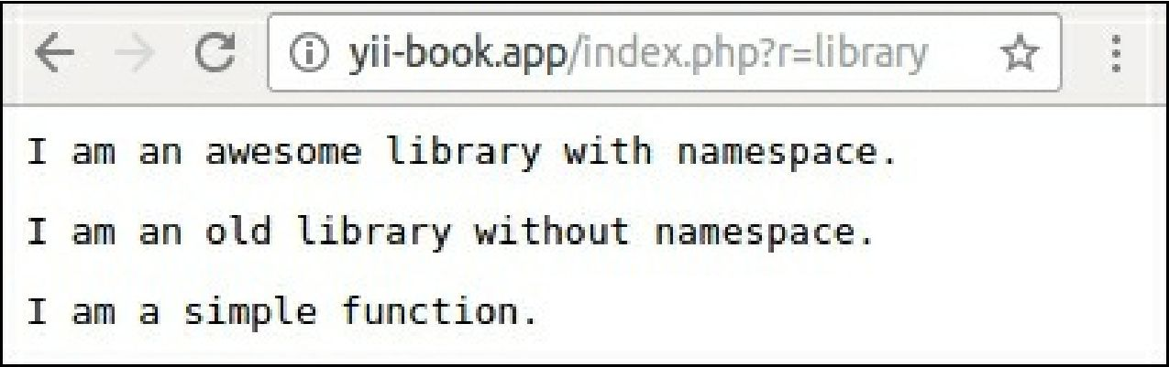

This example completely uses Composer’s autoloader instead of the framework’s autoloader.

See also

• For more information about integrating external code in Yii2 and framework code into our projects see the guide at <http://www.yiiframework.com/doc-2.0/guide-tutorial-yii-integration.html>

• For more on aliases refer to <http://www.yiiframework.com/doc-2.0/guide-concept-aliases.html>

• [For more on the autoload section of composer.json refer to https://getcomposer.org/doc/01-basic-](https://getcomposer.org/doc/01-basic-usage.md%23autoloading) usage.md#autoloading

• And also you can browse or search any Composer packages on <https://packagist.org>